

**Salford Care Organisation  
Job Description & Person Specification**

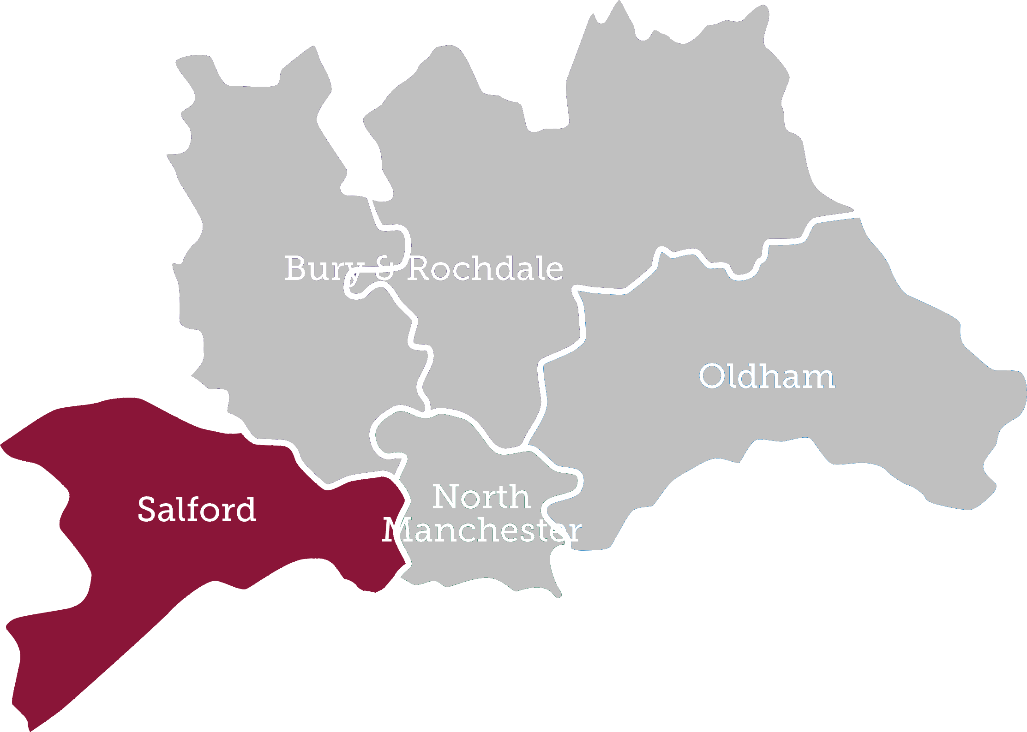

**Choose to make a Difference**  
Be developed • Be supported • Be inspired • Be empowered • Be rewarded • Make a difference





**We’re thrilled you’re thinking of joining us!**

Our new Northern Care Alliance NHS Group unites five local hospitals to deliver high quality care across the North East of Greater Manchester.

The Alliance provides the benefits of scale but delivers this locally through multiple hospital sites which make up four new Care Organisations – Bury/Rochdale, North Manchester, Oldham and Salford. Using our mantra of ‘Saving lives, Improving lives’, the aim is for our Care Organisations to work closely with the communities they serve to deliver safe, high quality and reliable care, which are trusted, connected and pioneering.

Our Care Organisations are designed to operate within our group arrangement of hospitals, community and healthcare services which bring together over 17,000 staff and the services of The Pennine Acute Hospitals NHS Trust and Salford Royal NHS Foundation Trust. Our size and geographical reach means we are creating an environment each individual will be inspired and empowered by to be the best they can be. This is a really exciting time to join our new team.

Salford Royal NHS Foundation Trust became only the second NHS Trust in the country and the first in the North of England to be rated “outstanding” by The Care Quality Commission. The Trust is consistently rated as one of the best places to work in the NHS and here are just a few of the reasons why:

* We are a major teaching hospital for the Universities of Salford & Manchester
* Our clear aim is to be the safest organisation in the NHS.
* Recent investment of £200 million to develop our main hospital site.
* Leading Major Trauma Centre for Greater Manchester
* Largest Dermatology Centre in Europe
* One of the most digitally mature Trusts in England (NHS England Digital Maturity Index).
* We are also an award winning Trust having been confirmed the best performing hospital in the North West and among the top 4% in England by the Healthcare commission, named Top Teaching Trust in England by Healthcare 100 and named a winner of the National Patient Safety Award.

The Trust has many nationally and internationally renowned clinicians who are pioneering the latest techniques and treatments. The Trust has an excellent reputation for quality and innovative clinical services, teaching and research.

**Our Values**We have four core values which are a focus for how our staff and volunteers work with each other to provide care for our patients. We think of our values as a set of guiding principles to refer to when making decisions and interacting with people and they help us to work together to continuously improve the organisation and ourselves.

These core values form part of the Organisations Performance Framework which regularly reviews how staff are performing.

**Patient & People Focus**

This value enables us to place the patient first we everything we do.

All staff are required to demonstrate that they:

* Communicate effectively with patients, families and colleagues
* Pro-actively personalise the service, connecting with patients and carers
* Adopt and practice the ‘safe, clean, personal’ ethos.

**Continuous Improvement**

This value ensures that the organisation including individual staff are always moving forwards and improving the ways things are done.

All staff are required to demonstrate that they:

* Look at ways of measuring and auditing improvements
* Pro-actively develop goals and objectives in support of the Trust’s vision
* Identify opportunities to reduce waste and inefficiency.

**Accountability**This value enables us all to recognise our own part in keeping our organisation ‘safe, clean and personal’ in the way we care for people.

All staff are required to demonstrate that they:

* Are transparent and results focused
* Display personal accountability towards problem-solving
* Recognise and accept accountability beyond job role.

**Respect**  
This value is about respecting patients and colleagues alike, and also the on-going reputation of the organisation.

All staff are required to demonstrate that they:

* Are supportive and empower staff involvement
* Are consistent and understanding of others and their needs

**Job Description**

**Job Title:** Smoking Cessation Nurse

**Band:** Agenda for Change Band 5

**Reports to:** Respiratory Nurse Team

**Responsible to:** Respiratory Nurse Team Lead

**Base/Department: Various – see advert**

**Main purpose of the job:**

The post holder will assist clinical teams in providing smoking cessation support to help smokers who want to stop smoking and delivering programmes of care to help stop smoking in line with the CURE project

As a nurse you will assist in the management and organisation of work as required, ensuring effective communication is maintained at all times, providing support for junior staff. You will play a key role in the supervision and assessment of all learners and unregistered staff, providing a teaching role.

**Main Tasks & Overview of Responsibilities**

* Using your clinical experience and skills you will be responsible for the assessment, planning, delivery and evaluation of programmes of care Assist clinical teams in providing smoking cessation support to help smokers who want to stop smoking and delivering programmes of care to help to stop smoking in line with the CURE project
* You will assist in the management and organisation of work, as required, ensuring effective communication is maintained at all times and will provide support for junior staff on the ward (newly qualified staff will receive initial support)
* You will play a key role in the education, development, mentorship and supervision and assessment of all learners and unregistered staff
* You will undertake nursing interventions consistent with evidence based practice, transferring and applying knowledge and skills to meet patients’ needs
* Be able to work collaboratively with all members of the MDT (Multi-Disciplinary Team) and to make referrals as appropriate
* To provide support and care for the patient and his/her family respecting their need for privacy and dignity
* To monitor the effectiveness of nursing care and adjust the programmes of care where indicated
* To utilise highly developed clinical skills specific to smoking cessation and maintain level 3 NSCST training and contribute to the development of others
* You will practice in accordance with the professional, ethical and legal framework for nursing

**Communications and Relationships**

* To communicate with people in an appropriate manner to ensure level of understanding incorporates preferred ways of communicating, culture and background
* To effectively communicate complex and sensitive information.
* To agree the arrangements for communication with the patient/family/carer, and to document these in accordance with Trust policy and the patients right to confidentiality
* To influence and prioritise the development of knowledge, ideas and work practice in self and others
* To competently receive sensitive information concerning patient’s medical condition and provide information using persuasive, reassuring skills as required, where barriers exist e.g. bereavement / special needs / learning disabilities / where English is not the first language
* To ensure that essential information on the patients’ condition and progress is recorded by self and team members appropriately according to NMC guidelines
* To communicate with a wide range of people to explore complex issues and to make complex decisions
* To encourage others to seek advice and solutions

**Analytical and Judgmental Skills**

* To undertake data collection effectively using the agreed system
* To use judgemental skills to decide upon and recommend best course of action including escalation as appropriate
* Undertake initial patient assessments, considering their health, safety and well-being and devising and delivering care plans, where there are a number of options
* Analyse situations and instigate emergency procedures as required

**Planning and Organisational Skills**

* To prioritise the care requirements for identified patients
* To monitor the work and performance of junior colleagues providing constructive feedback, advice and on-going support
* To monitor progress of work recognising changing priorities and implement corrective actions within own limits and informing the relevant people
* To assist in the management and organisation of work as required
* To organise and monitor the work and performance of junior colleagues providing constructive feedback, advice and on-going support
* To monitor progress of work recognising changing priorities and implement corrective actions within own limits and informing the relevant people.

**Physical Skills**

* Driving skills needed for community posts

**Responsibility for Patient Care**

* To assess, plan, implement and evaluate the physical, social and psychological condition of the patient and /or carer from admission to discharge
* To practice in accordance with the professional, ethical and legal framework for nursing
* To discuss and agree short, medium or long term goals, prioritise care and develop plans with the patient, family carer and health care team
* To support patients / carers encouraging them to promote their own health and wellbeing and to express their interests and concerns
* To undertake nursing interventions consistent with evidence based practice, transferring and applying knowledge and skills to meet patient’s needs
* To provide support and care for the patient and his / her family respecting their need for privacy and dignity
* To monitor the effectiveness of nursing care and adjust the programmes of care where indicated

**Responsibility for Policy/Service Development**

* To adhere to policies and procedures relating to own workplace
* To offer constructive views on how the existing service and team work can be evaluated and improved upon
* To contribute to service development

**Responsibilities for Financial and Physical Resources**

* To ensure effective use of material resources/supplies in consultation with senior staff
* To ensure patients valuables and belongings are documented and managed according to trust policy
* To monitor, control and store resources / supplies according to the requirements and specifications of the clinical environment

**Responsibilities for Human Resources**

* To assess and identify own development needs with support of mentor in relation to knowledge and skills required to meet the demands of the job
* To take responsibility for their own continuing professional development and maintenance of personal development plan
* To undertake annual mandatory training updates and other relevant courses in line with Trust and local policies
* To act as a role model and support professional development of all students and junior staff
* To act as a mentor to assigned learners and support them through their competency assessments as required
* Responsible for providing day to day co-ordination of clinically based staff/learners
* To report performance issues to the department manager
* To ensuring behaviours in the department reflect the Trust’s values
* To assume responsibility and management of the clinical environment in the absence of the manager
* To ensure appropriate staffing cover for emergencies over a 24 hour period
* To allocate work, assess performance and provide clear feedback to team members
* To contribute to team culture positively

**Responsibility for Information Resources**

* To record data accurately using the agreed systems i.e. Patient Administration System (PAS) and the Electronic Patient Record system (EPR) and paper documentation

**Responsibilities for Research and Development  
  
Quality**

* To ensure own actions promote quality and alert others to quality issues
* To participate in setting and maintaining optimal standards of care on the ward/unit
* To keep up to date and act consistently with quality standards and guidelines
* To have an understanding of the quality agenda and how standards of care can be maintained
* To monitor the quality of work in own area and bring to the attention of others quality issues
* To contribute effectively to evaluation studies (e.g. patient satisfaction surveys)

**Audit**

* To participate in audit / benchmarking within the clinical area supporting the introduction of a change in practice as appropriate

**Freedom to Act**

* Work is managed rather than supervised and can act independently within appropriate occupational guidelines
* To undertake all duties having regard to the NMC ‘Code of Professional Conduct’ for the nurse, midwife and health visitor and their professional contribution to Clinical Governance
* Is guided by Alliance protocols and codes of conduct.

**Partnership Working**

* The requirement to interact with others in order to achieve the objectives or purpose of the post. This will range from co-operating with other team members to multi agency working.

**Equality and Diversity**

* To recognise the importance of people’s rights and interpret them in a way that is consistent with trust procedures, policies and legislation
* To challenge behaviour that infringes the rights of others
* To identify and take action where necessary to address discrimination and oppression

**Making Every Contact Count**

* Front line staff are in an ideal position to offer support and advice on how to improve health and wellbeing
* Staff should engage with patients, relatives, carers and the public to give them additional advice on health and wellbeing
* Staff will be given support to help them to signpost people to other services which may improve their health and wellbeing.

**Health & Safety**

* To assist in maintaining health, safety and security of self and others in own work area
* To ask for help and take immediate and appropriate action in relation to any adverse incidents within the workplace
* Report any issues that may put health and safety at risk utilising the adverse incident reporting system.
* To work within legislation and trust procedures on risk management
* You have a personal responsibility to support your department/ward/clinic in reducing infection. You must comply with the Trust’s policies on infection, prevention and control. You must maintain your competence in relation to infection control and highlight any issues to your manager.

**General Staff**

* You have a personal responsibility to support your department/ward/clinic in reducing hospital acquired infection. You must comply with the Alliance’s policies on infection, prevention and control and maintain your competency to effectively discharge your responsibilities. You must bring deficiencies to the attention of your manager.

**Safeguarding**

* The Northern Care Alliance is committed to safeguarding and promoting the welfare of children, young people and vulnerable adults and expects all staff and volunteers to share this commitment.  You will be expected to fulfill your mandatory safeguarding training at the level applicable to this role.

**Electronic Patient Record**

* The Northern Care Alliance uses an Electronic Patient Record (EPR). All Clinicians must use EPR as the primary patient record. It supports delivery of Safe, Clean and Personal patient care. Paper is used only for clinical record components (e.g. fluid charts) that do not at present have an EPR replacement.
* The majority of clinical documentation is entered directly on the EPR including health issues, case histories and continuation notes, condition specific structured records and risk assessments. EPR also provides systems for prescribing, requesting most tests and some services, and for viewing results, a local integrated record and correspondence.
* Access to this comprehensive EPR is via a unique login and password. All Clinicians working at the Northern Care Alliance must receive EPR training.

**Code of Conduct**

* Professional staff that have a national Code of Conduct are expected to adhere to that Code and failure to do so could result in disciplinary action being taken. Staff who do not have a regulatory body are expected to conduct themselves in a professional manner and in line with the Trust values and polices are all time.

**Person Specification**

|  |  |  |  |
| --- | --- | --- | --- |
|  | **Specification** | **Essential / Desirable** | **Evidence** |
| **Registration** | Registered Nurse with current NMC registration (Part 1 Adult / General Level 1 or 2) | **E** | Nursing Registration |
| **Essential Qualifications** | Degree / diploma in nursing studies(or equivalent nursing qualification and experience)  Evidence of continuous professional  development (CPD)  Evidence of involvement in teaching  Evidence of mentorship qualification | **E**  **D**  **D**  **D** | Certificate  Application Form / Interview  Application Form / Interview  Certificate |
| **Knowledge, Skills and Experience** | Demonstrates evidence based clinical knowledge  IT Skills  Communicates succinctly, clearly and accurately both verbally and in writing  Be an effective team member who is able to relate to colleagues at all levels of the Trust with tact and diplomacy  Ability to coordinate your workload and supervise members of the team, ensuring high quality, safe and effective patient care  Experience of the use of clinical systems  Demonstrate initiative to proactively problem solve with a solution focus  Ability to use reflective practice, to continuously improve the standard of patient care | **E**  **E**  **E**  **E**  **E**  **D**  **D**  **D** | Application Form / Interview  Application Form / Interview  Application Form / Interview  Application Form / Interview  Application Form / Interview  Application Form / Interview  Application Form / Interview  Application Form / Interview |

**Physical & Mental Requirements**

|  |  |
| --- | --- |
| **Physical effort:**  The post holder will be required to exert frequent moderate physical effort for several short periods during a shift e.g. moving patients over 15 kilos with mechanical aids  **Mental effort:**  To exert frequent concentration where the work pattern is unpredictable e.g. calculating drug doses for infuses and dealing with unpredictable patient / relative behaviours | **Emotional effort:**  The post holder will at times be exposed to distressing and occasional highly distressing and emotional circumstances, caring for patients with life limiting conditions  **Working conditions:**  Frequent exposure to unpleasant working conditions/hazards e.g. uncontainable body fluids, physical and verbal aggression |

**Interview Criteria**

|  |  |
| --- | --- |
| Criteria | **Importance**  ***(High, medium, or low)*** |
| Able to demonstrate the Trust Values | High |
| Able to deliver a high standard of evidence based individual patient care | High |
| Basic IT skills | High |
| Committed to own personal continuing professional development (CPD) | Medium |
| Effective communicator with good interpersonal skills and initiative | High |
| Evidence of involvement in teaching and mentoring learners | Medium |
| Effective team member who is able to relate to colleagues at all levels of the Trust with tact and diplomacy | High |