

**Salford Care Organisation  
Job Description & Person Specification**

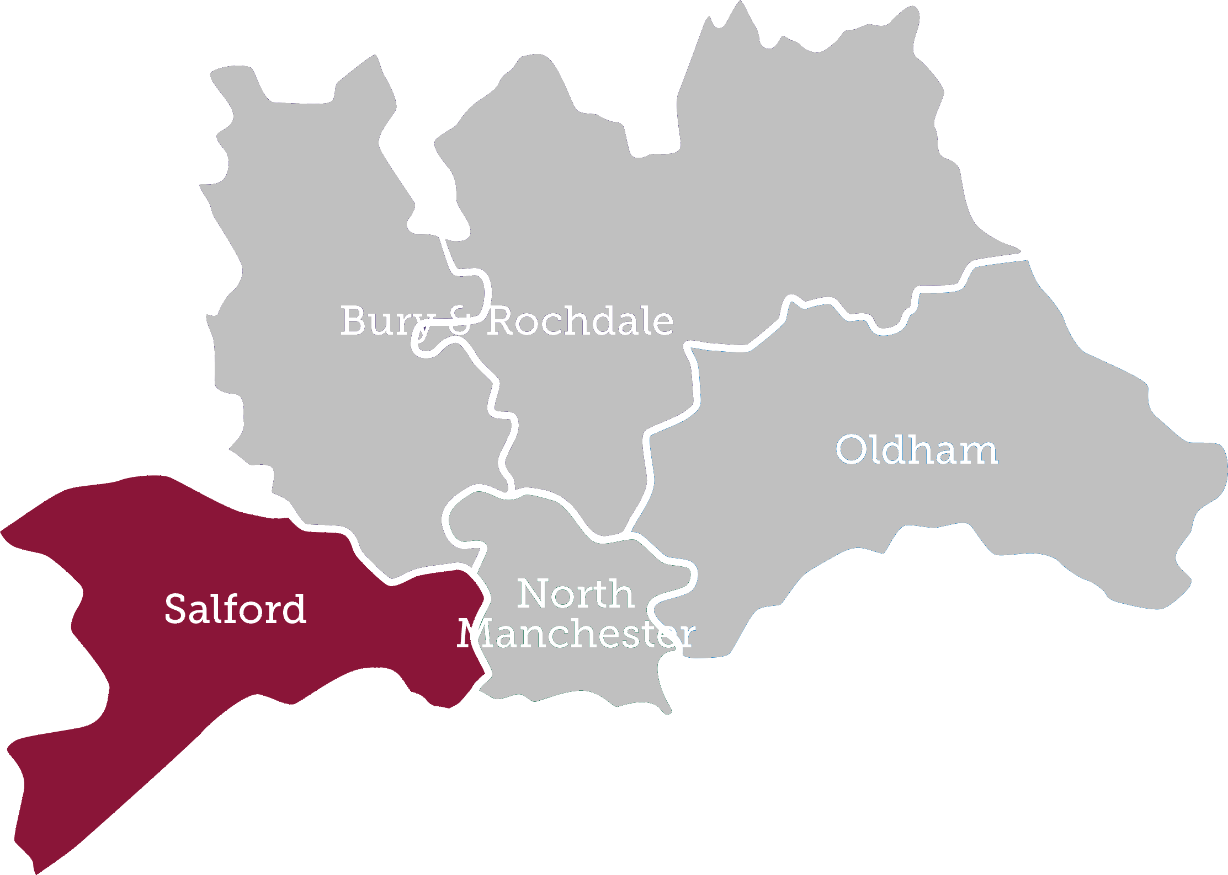

**Choose to make a Difference**  
Be developed • Be supported • Be inspired • Be empowered • Be rewarded • Make a difference



**We’re thrilled you’re thinking of joining us!**

Our new Northern Care Alliance NHS Group unites five local hospitals to deliver high quality care across the North East of Greater Manchester.

The Alliance provides the benefits of scale but delivers this locally through multiple hospital sites which make up four new Care Organisations – Bury/Rochdale, North Manchester, Oldham and Salford. Using our mantra of ‘Saving lives, Improving lives’, the aim is for our Care Organisations to work closely with the communities they serve to deliver safe, high quality and reliable care, which are trusted, connected and pioneering.

Our Care Organisations are designed to operate within our group arrangement of hospitals, community and healthcare services which bring together over 17,000 staff and the services of The Pennine Acute Hospitals NHS Trust and Salford Royal NHS Foundation Trust. Our size and geographical reach means we are creating an environment each individual will be inspired and empowered by to be the best they can be. This is a really exciting time to join our new team.

Salford Royal NHS Foundation Trust became only the second NHS Trust in the country and the first in the North of England to be rated “outstanding” by The Care Quality Commission. The Trust is consistently rated as one of the best places to work in the NHS and here are just a few of the reasons why:

* We are a major teaching hospital for the Universities of Salford & Manchester
* Our clear aim is to be the safest organisation in the NHS.
* Recent investment of £200 million to develop our main hospital site.
* Leading Major Trauma Centre for Greater Manchester
* Largest Dermatology Centre in Europe
* One of the most digitally mature Trusts in England (NHS England Digital Maturity Index).
* We are also an award winning Trust having been confirmed the best performing hospital in the North West and among the top 4% in England by the Healthcare commission, named Top Teaching Trust in England by Healthcare 100 and named a winner of the National Patient Safety Award.

The Trust has many nationally and internationally renowned clinicians who are pioneering the latest techniques and treatments. The Trust has an excellent reputation for quality and innovative clinical services, teaching and research.

**Our Values**We have four core values which are a focus for how our staff and volunteers work with each other to provide care for our patients. We think of our values as a set of guiding principles to refer to when making decisions and interacting with people and they help us to work together to continuously improve the organisation and ourselves.

These core values form part of the Organisations Performance Framework which regularly reviews how staff are performing.

**Patient & People Focus**

This value enables us to place the patient first we everything we do.

All staff are required to demonstrate that they:

* Communicate effectively with patients, families and colleagues
* Pro-actively personalise the service, connecting with patients and carers
* Adopt and practice the ‘safe, clean, personal’ ethos.

**Continuous Improvement**

This value ensures that the organisation including individual staff are always moving forwards and improving the ways things are done.

All staff are required to demonstrate that they:

* Look at ways of measuring and auditing improvements
* Pro-actively develop goals and objectives in support of the Trust’s vision
* Identify opportunities to reduce waste and inefficiency.

**Accountability**This value enables us all to recognise our own part in keeping our organisation ‘safe, clean and personal’ in the way we care for people.

All staff are required to demonstrate that they:

* Are transparent and results focused
* Display personal accountability towards problem-solving
* Recognise and accept accountability beyond job role.

**Respect**  
This value is about respecting patients and colleagues alike, and also the on-going reputation of the organisation.

All staff are required to demonstrate that they:

* Are supportive and empower staff involvement
* Are consistent and understanding of others and their needs

**Job Description**

**Job Title:** Smoking Cessation Advisor

**Band:** Agenda for Change Band 2

**Reports to:** Respiratory Nurse Team

**Responsible to:** Respiratory Nurse Team Lead

**Base/Department: SRFT**

**Main purpose of the job:**

All patients admitted to SRFT should have their smoking status recorded and their smoking habits documents in line with the public health agenda. The post holder will assist clinical teams in providing smoking cessation support to help smokers who want to stop smoking, quit

**Main Tasks & Overview of Responsibilities**

* Establish and maintain communication with patients, relatives and carers, working in partnership with the multidisciplinary team to provide holistic patient care
* Contribute to own personal development
* Assist in maintaining own and others’ health, safety and security
* Contribute ideas for service improvement
* Ensure own actions help to maintain quality and patient safety
* Undertake routine assessment tasks related to individuals’ health and well-being, making modifications within prescribed parameters and reporting back to Senior Staff on patients’ progress
* Assist in delivering programmes of care to meet individuals’ health and well-being needs, promoting patient independence as appropriate, in partnership with the multidisciplinary team.
* Ability to work flexibly and unsociable hours to meet the demands of the service

**Communications and Relationships**

* To communicate with people clearly in a manner and at a level of understanding appropriate to their abilities, preferences and beliefs
* To actively listen and respond to the needs of patients, relatives and carers
* To provide assistance to patients, relatives and carers, utilising persuasive skills, reassurance, tact and empathy as required
* To communicate information only to those people who have a right and a need to know, respecting confidentiality, in line with SRFT policy and procedure

**Analytical and Judgmental Skills**

* To actively assess peoples’ health, safety and wellbeing whilst delivering personal care
* Recognise when there is a change in an individual’s health and well- being, requiring referral to a senior member of staff

**Planning and Organisational Skills**

* To organise their own day to day duties
* To prioritise the care and enablement requirements for identified patients
* To assist in the organisation of work as required

**Responsibility for Patient Care**

* To correctly undertake tasks that have been delegated
* To record information accurately and pass it to the relevant people in the team in a timely manner
* To identify and report any changes that might affect the patient’s health and well-being or any possible risks that NRT may pose
* To obtain agreement from patient/carers before commencing any care related tasks
* To respect the individual’s privacy, dignity and beliefs.
* To prepare and support the patient appropriately during any activity that is to be undertaken facilitating patient independence and enablement as appropriate.
* To promptly alert the team where there are any changes in the patient’s health and well­being or any possible risks

**Responsibility for Policy/Service Development**

* To apply trust policies and procedures relating to own workplace
* To offer constructive views on how the existing service and team work can be improved upon
* To contribute to service development

**Responsibilities for Financial and Physical Resources**

* To ensure effective use of material resources/supplies within the work area in consultation with senior staff
* To ensure patients valuables and belongings are documented and managed according to trust policy, where appropriate
* To order resources/supplies according to the requirements and specifications of the clinical environment

**Responsibilities for Human Resources**

* To identify with the help of others own development needs and take responsibility for own continuing learning, development and performance
* To undertake annual mandatory training updates and other relevant courses in line with Trust and local policies, in a timely manner
* To take an active part in learning opportunities and keep a personal development portfolio
* To seek help and advice when unsure
* Demonstrate own activities to new or less experienced employees
* Take on additional responsibilities as per competency framework

**Responsibility for Information Resources**

* To record data accurately using the agreed systems i.e. Patient administration system (PAS), paper records, electronic records.
* To contribute to updating of patients records

**Responsibilities for Research and Development**

**Quality**

* To ensure own actions promote quality and alert others to quality issues
* To participate in setting and maintaining optimal standards of care on the work area
* To have an understanding of how to maintain standards of care

**Audit**

* To participate in audit/benchmarking within the clinical area supporting the introduction of a change in practice if indicated

**Freedom to Act**

* Carries out routine personal care duties to set standards, using own initiative safely
* Works to established protocols, practices and procedures.
* Work is supervised within the acute setting. In the community setting, work is not always supervised but support is available

**Partnership Working**

* The requirement to interact with others in order to achieve the objectives or purpose of the post. This will range from co-operating with other team members to multi agency working

**Equality and Diversity**

* To act in ways that are consistent with trust procedures, policies and legislation
* To treat all patients, relatives, carers and staff with respect, dignity and understanding
* To act in ways that recognise people are different and not to discriminate against people because of those differences

**Making Every Contact Count**

* Front line staff are in an ideal position to offer support and advice on how to improve health and wellbeing
* Staff should engage with patients, relatives, carers and the public to give them additional advice on health and wellbeing
* Staff will be given support to help them to signpost people to other services which may improve their health and wellbeing.

**Health & Safety**

* To monitor and maintain health, safety and security of self and others in own work area
* To identify and assess potential risks in work activities and how to manage these risks appropriately
* To work within legislation and trust procedures on risk management
* To take immediate and appropriate action in relation to adverse incident reporting utilising the hospital incident reporting system.
* You have a personal responsibility to support your department/ward/clinic in reducing hospital acquired infection. You must comply with the Trust’s policies on infection, prevention and control and maintain your competency to effectively discharge your responsibilities. You must bring deficiencies to the attention of your manager
* You are accountable for the effective deployment of activities that ensure that your department/ward/clinical team is reducing hospital acquired infection. You will ensure that you and your staff comply with the Trust’s policies on infection, prevention and control. You will ensure that you and your staff receive the training required to maintain competence to execute the Trusts policies on infection, prevention and control. You have a responsibility to bring deficiencies in the deployment of such policies to the attention of your line manager

**General Staff**

* You have a personal responsibility to support your department/ward/clinic in reducing hospital acquired infection. You must comply with the Trust’s policies on infection, prevention and control and maintain your competency to effectively discharge your responsibilities. You must bring deficiencies to the attention of your manager.

**Safeguarding**

* The Trust is committed to safeguarding and promoting the welfare of children, young people and vulnerable adults and expects all staff and volunteers to share this commitment.  You will be expected to fulfill your mandatory safeguarding training at the level applicable to this role

**Electronic Patient Record**

* The Northern Care Alliance uses an Electronic Patient Record (EPR). All Clinicians must use EPR as the primary patient record. It supports delivery of Safe, Clean and Personal patient care. Paper is used only for clinical record components (e.g. fluid charts) that do not at present have an EPR replacement.
* The majority of clinical documentation is entered directly on the EPR including health issues, case histories and continuation notes, condition specific structured records and risk assessments. EPR also provides systems for prescribing, requesting most tests and some services, and for viewing results, a local integrated record and correspondence.
* Access to this comprehensive EPR is via a unique login and password. All Clinicians working at the Northern Care Alliance must receive EPR training.

**Code of Conduct**

* Professional staff that have a national Code of Conduct are expected to adhere to that Code and failure to do so could result in disciplinary action being taken. Staff who do not have a regulatory body are expected to conduct themselves in a professional manner and in line with the Trust values and polices are all time.

**Person Specification**

|  |  |  |  |  |
| --- | --- | --- | --- | --- |
|  | **Specification** | **Criteria** | | **Evidence** |
| **Essential** | **Desirable** |
| **Registration** | No registration required |  |  | N/A |
| **Essential Qualifications** | NVQ Level 2 (or equivalent  experience) |  |  | Certificate |
| Level 1 Literacy and Numeracy (GCSE Engligh and Math’s Grade D-G) |  |  | Certificate |
| Care Certificate |  |  | Certificate |
| **Knowledge, Skills, Training and Experience** | Good communication skills |  |  | Application/ interview |
| The ability to converse at ease with members of the public and provide advice in accurate spoken English is essential for the post |  |  | Application/ interview |
| Experience of working with members of the public or a desire to work in the Health Service |  |  | Application/ interview |
| Understanding of routine work procedures gained through a short induction period and on the job training |  |  | Application/ interview |
| Basic IT Skills |  |  | Application/ interview |
| Experience of working within a health or social care environment |  |  | Application/ interview |
| Experience of working within a team |  |  | Application/ interview |
| Good organisational skills |  |  | Application/ interview |
| Commitment to undertaking continuous professional development (CPD) |  |  | Application/ interview |

**Physical & Mental Requirements**

|  |  |
| --- | --- |
| **Physical effort:**  The post holder will be required to exert frequent moderate physical effort for several short periods during a shift e.g. moving patients over 15 kilos with mechanical aids | **Emotional effort:**  The post holder will at times be exposed to distressing and occasional highly distressing and emotional circumstances, caring for patients with life limiting conditions |
| **Mental effort:**  To exert frequent concentration where the work pattern is unpredictable e.g. care of patients with chronic illness and dealing with challenging behaviours | **Working conditions:**  Frequent exposed to unpleasant working conditions/hazards e.g. uncontained body fluids, physical and verbal aggression |